9

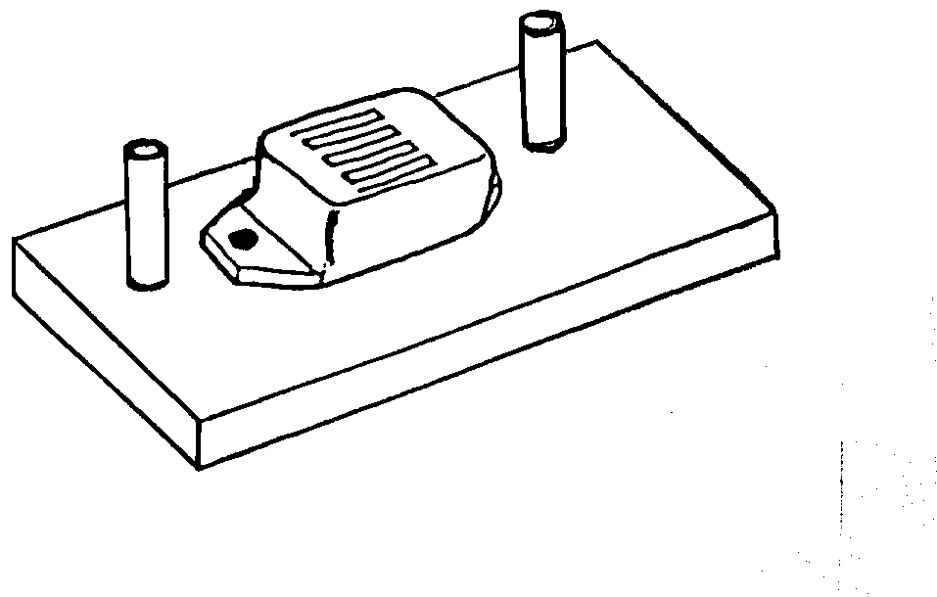
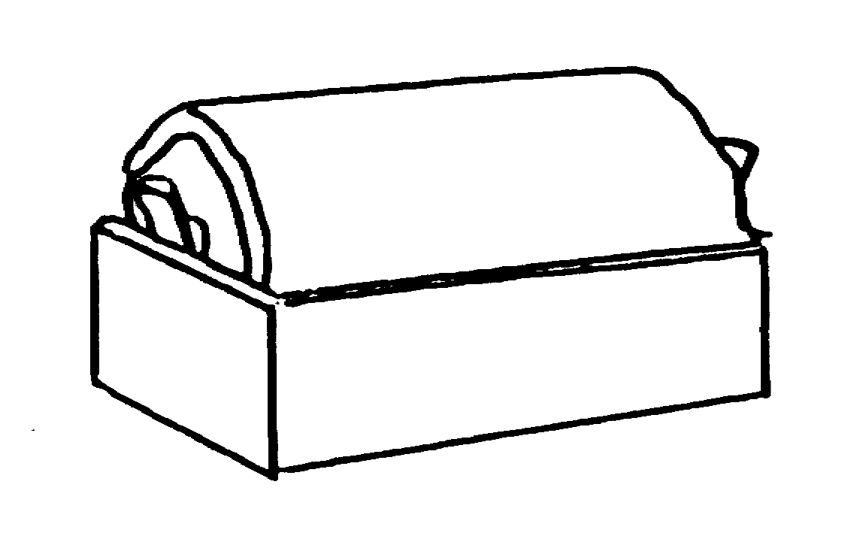
The buzzer in the first circuit is on. For each of the other circuits, tick one box () to show if the buzzer is on or off.
.

off
on
3
off
on
.

off
on
.

off
on

a. b.

c. d.

.

e.

.

off
on

